DON MILLIGAN’S
Off The Cuff
October 11, 2026

Ethnonationalism
What is it?

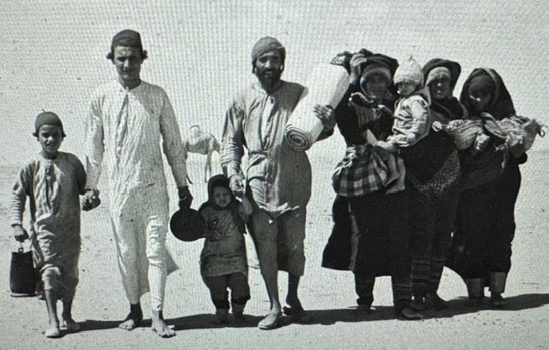
IRAQI JEWS HEADING FOR ISRAEL IN 1948

THE GREEN PARTY is now resolutely opposed to ethnonationalism. This is because:

“. . . ethnonationalism, privileges one ethnic group on the basis of the subjugation
of others.”

In adopting this position, the Green Party is accusing Israel of subjugating its two million Arab citizens, including the country’s religious minorities: Christians (2%), Muslims (19%), and Druze (2%).
It is not clear to what extent Israel’s minorities are subjugated or oppressed.
It is true that Jews are privileged by the Law of Return which affords Jews, worldwide, the right to enter and settle in the Jewish state. This does not apply to people of other faiths and ethnicities. It is also claimed that housing, local government, and educational budgets, are restricted or lower in the country’s minority neighbourhoods. All this may be true, but it is not clear whether these inequalities pass muster as “subjugation” or “oppression”.
Israel is, of course, a Jewish state. And, this inevitably must entail privileges to Jews which are not enjoyed by non-Jews. But it remains the case, that the right to vote and serve in the county’s armed forces, parliament, and judiciary, are not restricted to Jews, and are enjoyed by members of all minority communities.
However, the privileges accorded to Jews in Israel do violate conceptions of international human rights. This possibly explains Israel’s Basic Law, and the absence of a constitution. Yet, Israel remains democratic in a way that other ethnonationalist states do not.
In Saudi Arabia religious freedom is not guaranteed – on the contrary the rights of Shia Muslims are severely restricted and controlled by the state. Incidentally, only Muslims may be citizens. All religions other than Islam are prohibited, and Synagogues, Churches, Hindu Temples, or places of worship for any other religion are, by law, illegal.
Pakistan is slightly different. Formally, the country enjoys religious freedom, but all civil laws must be aligned with Muslim conceptions of Islamic Sharia law. Life imprisonment or execution, regardless of a person’s religion, is often imposed for any writing, speech, or action, deemed to be offensive to Islam, the Quran, or the Prophet Mohamad. Consequently, Christians, Ahmadis, Hindus, and Sikhs, do not, in practice, enjoy equal rights.
We could go on considering the status of minorities in country after country, and we would encounter many different circumstances, but it is clear that Israel would be the most democratic and the least restrictive amongst all so-called ethnonationalist states.
Israel was declared as a state during a war in which about 800,000 Arabs fled or were driven out by Jewish armed forces. Massacres occurred on both sides during the fighting; men, women, and children were murdered out of hand. This is, of course, the normal state of affairs in any war. It is particularly true during the process of state formation (or re-establishment) in Poland, Turkey, Pakistan, or China.
Ethnic cleansing is also widespread as nation states seek to establish coherent foundations for their novel polities. During Israel’s War of Independence thousands of Jews were ethnically cleansed from Judea and Samaria by the army of the Kingdom of Jordan who, along with Egypt, annexed all the territory in the Holy Land not seized by Israel. Between 1948 and 1967 all Jews were expelled from Old Jerusalem and what is now called the West Bank. This also occurred in Egypt, Iraq, and Syria. From 1948 all the states in the Arab world expelled Jews with a suitcase and the clothes they stood up in. Using the concept employed by Adolf Eichmann, Arabia and North Africa was Judenfrei by 1950 or there abouts.
This ethnic cleansing of Jews has resulted in sixty per cent of the Jewish population of Israel being descended from people born and raised in ancient Jewish communities in the Middle East and North Africa.
Despite the ignorant claims of the Palestine Solidarity movement, worldwide, Israel is not a colony of Europeans planted in Arab lands. Its population is made up of Jews who have lived in Jerusalem and the Holy Land for centuries, together with the descendants of refugees who were driven out of numerous countries from Russia to Iraq, and from cities like Cairo and Tunis. Israel was created by refugees from pogroms, massacres, and expulsions, as a homeland in which Jews could arm and defend themselves from genocidal violence.
Now, the Green Party, its leaders and rank and file, call Israel an apartheid state, guilty of ethnic cleansing of Arabs, and indeed of carrying out a genocide of Palestinians in Gaza and beyond. These claims are both malign and untrue. Zionism is not racist – some Zionists are obviously racist – like many members of the Green Party who wish to attack Jews and insist upon the destruction of the only Jewish state in the world.
Zionism is an ancient religious idea, but in its modern largely secular form, it appeared during the final decades of the nineteenth century in Europe. It arose as a battle between Jews who believed in Jewish Emancipation and Jews who sought safety in Jewish Nationalism. Until around 1930 Jewish Nationalism (Zionism) was a minority opinion amongst Jews worldwide. Most Jews put their trust in the idea of emancipation in the countries and societies where they lived. They sought equality and fought the right to live unfettered by social prejudice and discriminatory laws.
However, the failure of the struggle against fascism in Europe, and the virulent hatred of Jews in the Arab world, resulted by the mid-thirties in the majority of Jews swinging behind Jewish Nationalism – Zionism – as the only rational response to the veritable tsunami of killings and massacres. The failure of the Emancipation strategy was undeniable, and this resulted by 1948 in Zionism winning the great majority of Jews worldwide to support the founding the state of the Israel.
Consequently, there is something grotesque and simultaneously absurd about the Green Party accusing Israel and Zionism of being racist. This political party in Britain is now calling for the destruction of the Jewish state and its replacement by a Muslim state. They are calling for equality of Muslims and Jews in a new single state of Palestine covering what is now Israel, Judea, and Samaria. When faced by the Green Party’s scheme for the liquidation of Israel, one has to question the gullibility or sanity of those who dreamed it up.
Everybody knows full well that the Palestinians of Gaza, and the Palestinian Authority, are committed to the violent destruction of the Jewish state, and to the ethnic cleansing of Jews by murder and terror from what they regard as intrinsically Muslim lands. The attempt by the Green Party to banish such unfortunate thoughts and realities has revealed, paradoxically, the party’s racist character.
The party argues that it is opposed to what it calls ethnonationalism. Yet, it only attacks the ethnonationalism of the Jews. Saudi Arabia, Pakistan, and a good many other ethnonationalist states get a free pass; they do not attract the attention or ire of the Green Party. While they call for the establishment of an ethnonationalist state of Palestine, and the removal of Jews from Judea and Samaria (the West Bank) they concentrate all their attention on the so-called racism of Zionists.
In seeking the destruction of the Jewish state, the Green Party has come clean. It is an antisemitic party committed to the idea that the Jews have no right to self-defence and no right to self-government or self-determination.

